Brandon Tenorio

MATH280

Fall 2021

Professor Camilo J. Diaz

***Project 2***

***MatLab Code***

clc

clear

clear all

t=[0:100];

x=(8*t.^12);

y=sin(t/12);

z=8./(exp(t));

plot3(x,y,z);

***MatLab Screenshot***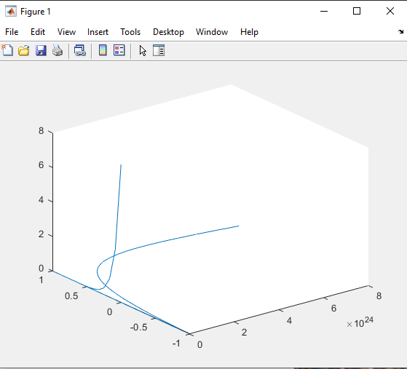

***Handwritten Work***